Supply and Demand Graph Activity

Note: Be sure to watch the Khan Academy video (https://youtu.be/UQVwgC7MAHM) on “Equilibrium Price” before beginning this assignment.

Prices and Government Policy
In a market, prices adjust up and down until they reach the equilibrium price. At this price, suppliers provide just enough of the good or service for all who want to buy it. However, sometimes government actions block the price adjustment process. For example, suppose a community has many low-income families. These families cannot afford an apartment at the equilibrium price set by the market. The government lowers the price to help more people obtain an apartment by setting a price ceiling on apartment rents. A price ceiling is a legal maximum that may be charged for something. Sometimes the government sets a price floor, or a legal minimum that may be charged for something. To help workers earn more, the government sets a minimum wage. This is the lowest amount employers may pay their workers. It is a price floor for wages.

Graph A shows the supply and demand for apartments in the example described above. Study the graph, then answer the 6 questions below.

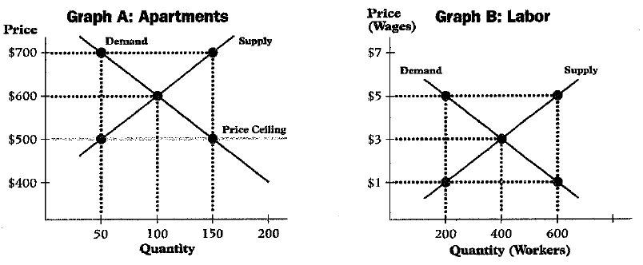

- In Graph A, what is the equilibrium price for apartments in this area?

- What price did the government set as the price ceiling?

- At the ceiling price, how many apartments would be supplied?

- At the ceiling price, how many apartments would people want?

- Is the result a surplus or shortage? Of what amount?

- CRITICAL THINKING ACTIVITY Graph B shows supply and demand for unskilled labor in an area. Suppose the government sets the minimum wage at $5 per hour. How would this government action affect supply and demand for labor in this area? (Watch the first 5:30 of this Khan Academy video [https://youtu.be/j0c2vmFGbtk] on “Minimum Wage & price floors” if you need help)

