Smart Sellers Create Demand

Customer preference--or taste--is a basic source of demand. Smart sellers are aware of customers' tastes and supply products that fit those tastes. Even if their product, such as ice cream, is similar to their competitors' products, smart sellers also need to be aware of the competition and create more demand for their product than their competitors.

Read the following steps that the owners of an ice cream shop might take to increase the demand for their product over other ice cream shops. Then answer the 8 questions below.
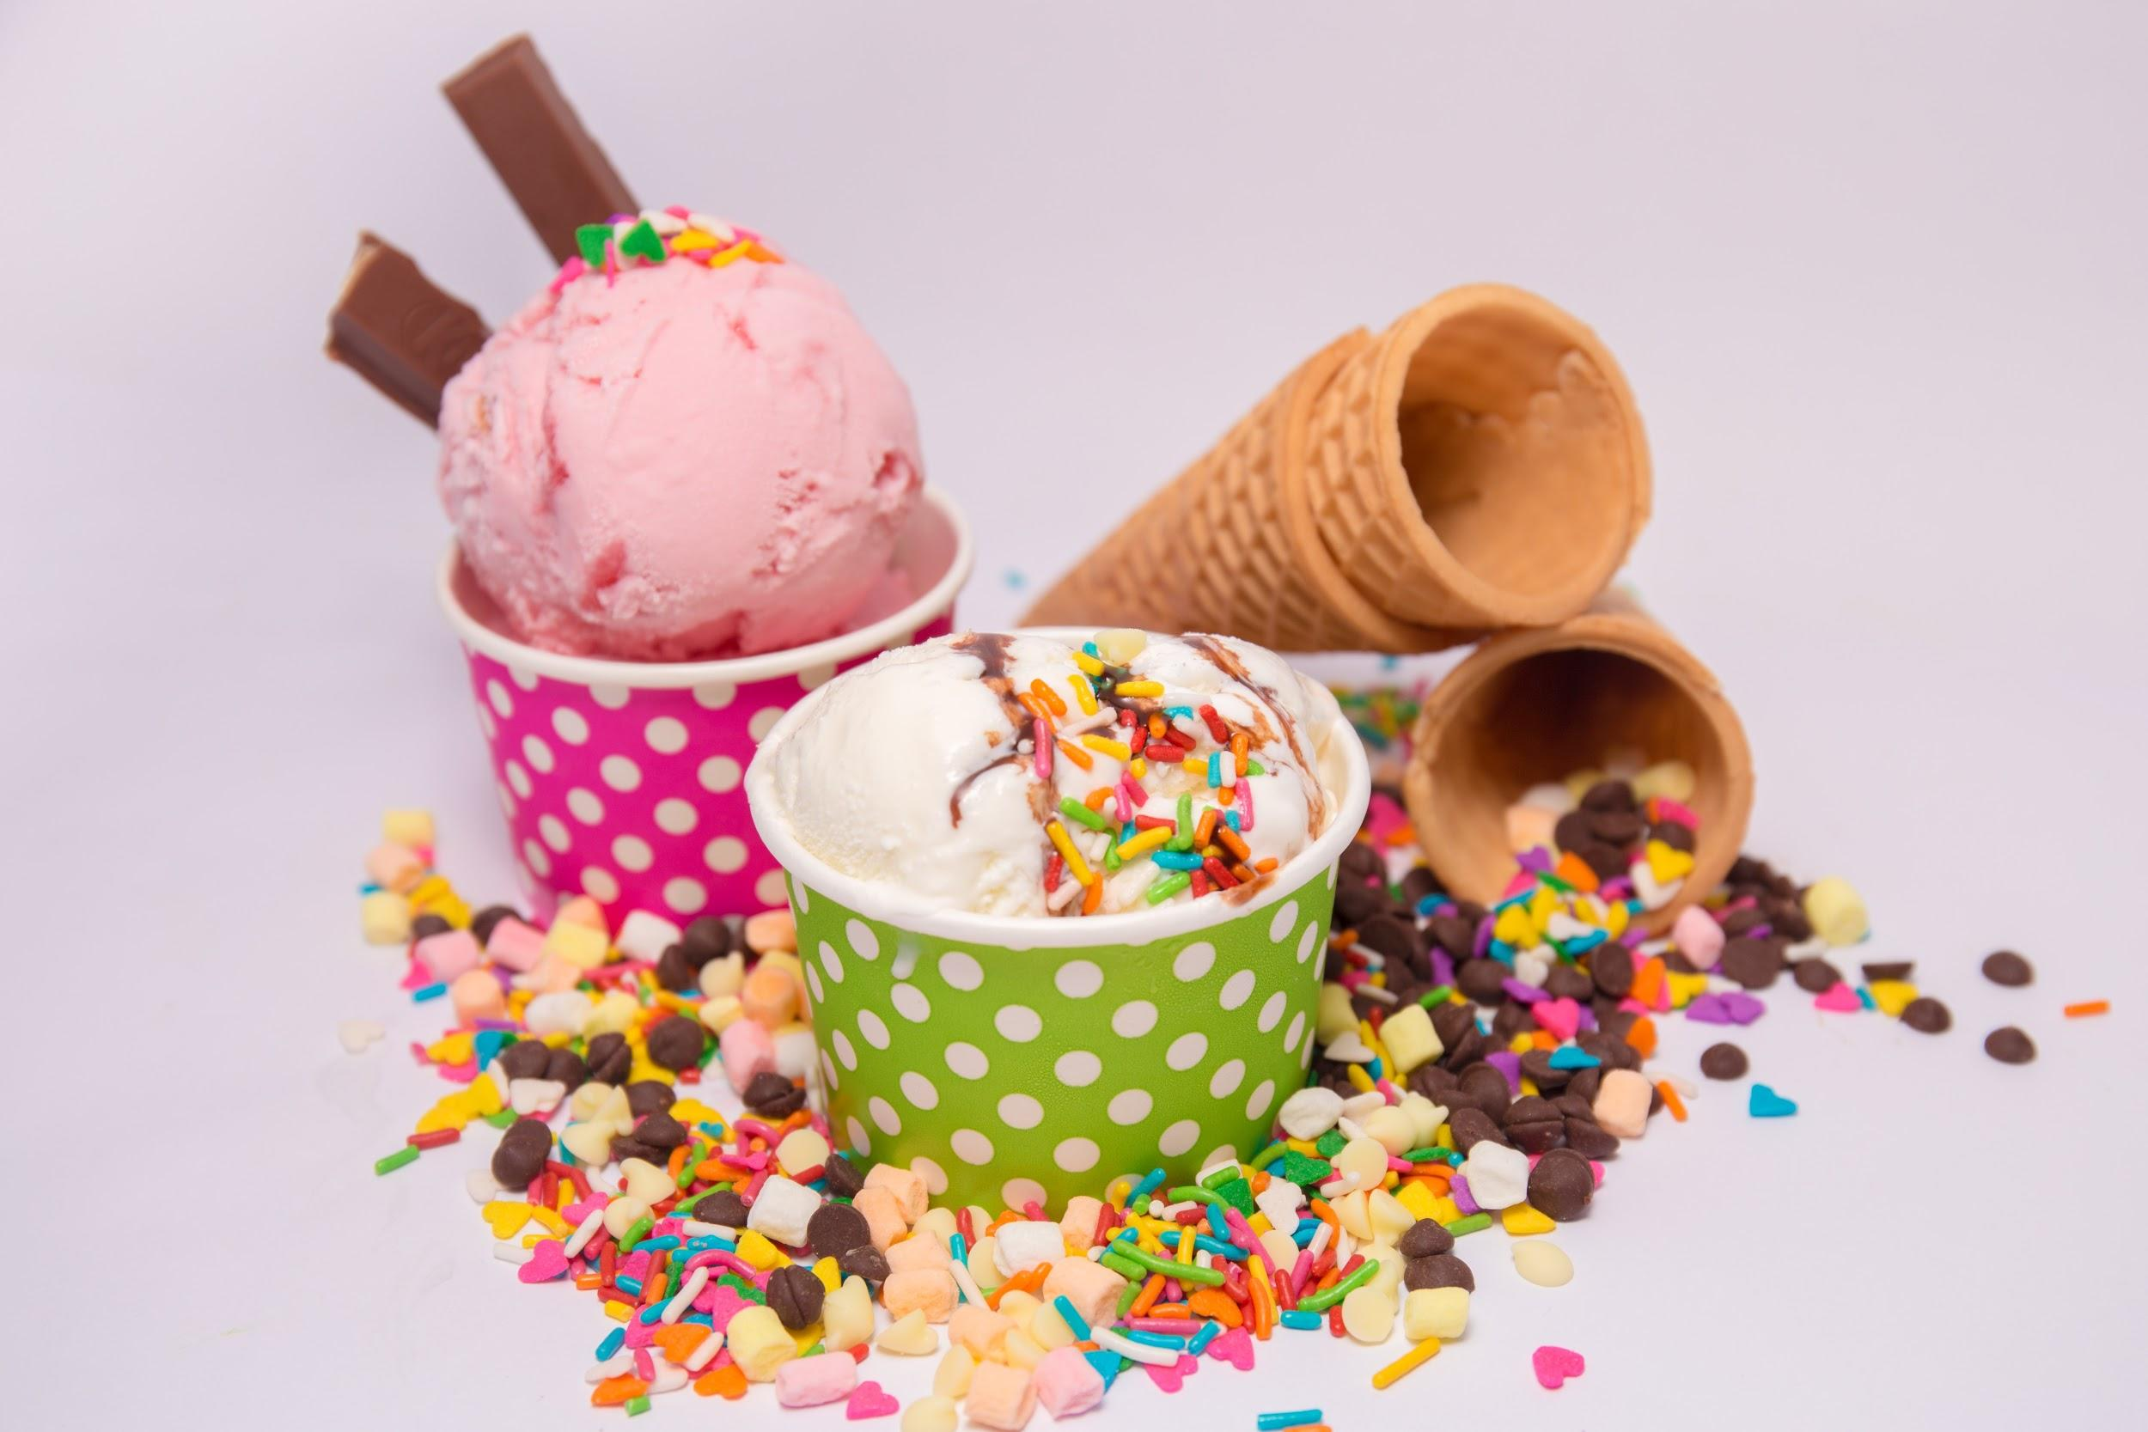
Ways to Increase Demand

- Be aware of customer taste. Offer the flavors that customers like the best
- Make a higher-quality ice cream.
- Add complementary products, such as a variety of cones and toppings.
- Sell different products. Provide frozen yogurt in addition to ice cream.
- Offer the customer lower prices than other ice cream shops.
- Offer convenience. Place the ice cream shop at a location that is closer to the customers than the other ice cream shops.

- As a customer of an ice cream shop, rate the above methods to increase demand from what is most important to you to what is least important.

- What products does the boxed information indicate might be used to complement the ice cream?

- What could the owner sell in addition to ice cream? Provide 3 examples of additional products to sell.

- CRITICAL THINKING Which methods would increase the shop owners' expenses? Explain how.

- CRITICAL THINKING Which method might be difficult to implement for a shop owner who has been in business for several years already? Why?

- CRITICAL THINKING List 3 ways the owner of the above ice cream shop can remain aware of their customers' tastes.

- CRITICAL THINKING A smart seller must also stay in touch with changing consumer preferences. Think of items you purchased or used often in the past, but have not purchased recently. List these items and what you purchase now instead of the old product. Explain why your preferences changed.

- CRITICAL THINKING Shopping malls often contain clothing shops with similar items. What do the shops use to visually create demand for their products along the walkways of the mall?

--
-
-
-
-
-
--
--

