Pool Reading Questions
1. What is the city planning to spend $150,000 on in regards to pools?

2. Critical Thinking: Why do you think attendance has been declining at the city swimming pools? Explain

3. Why will the plan look at the city’s swim lessons?

4. Critical Thinking: Why would the city want public input on this plan? Explain.

5. What is the operating budget of the public pools? How much money does it generate?

6. Critical Thinking: Do you think it is a good idea for the city to run public pools if they are losing money? Explain.

7. How many people went to a public pool in 2012? How many went in 2014?

8. What do some nearby cities like Georgetown have that Lexington does not?

9. Critical Thinking: What is one piece of advice you would give to city officials to make the city pools more popular? Explain.

As usage of city-owned pools declines, Lexington launches study to find out why
BY BETH MUSGRAVE
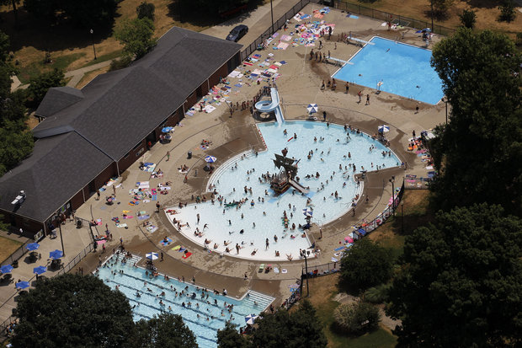
*Aerial view people escaping the heat at the Woodland pool in Lexington, Ky., Friday, July 6, 2012.
A comprehensive look at Lexington's aquatics program will likely begin this spring, city officials said this week.
The $150,000 plan will look at reasons behind declining attendance at the city's seven pools, the feasibility of starting an indoor aquatics center and adding other water features such as splash pads.
The master plan will also look at the city's swim lessons to determine if there are segments of the population that the program is not reaching.
Roger Daman, an administrator with the city, told the Urban County Council on Tuesday that a request for proposals for a consultant to conduct the study should be released by the end of February or early March.
Commissioner of General Services Geoff Reed, who is acting as head of the city's Parks and Recreation Department, said a completion date for the first major study of the city's aquatics program has not been set.
"I want to make sure that we get this right," Reed said. "We definitely want to make sure that there is plenty of opportunity for public input."
Reed said the consultants will be hosting several town-hall type meetings to gather input from residents about what they want.
"We want the consultants to be here during the summer months so they can see how pools are being used and be able to talk to people," Reed said.
The idea for a master plan for pools first came up last fall when the Urban County Council was discussing how to spend a budget surplus. There has been talk about adding a splash pad somewhere in the city, but there was disagreement on where to put it.
A master plan for the city's aquatics program will help the city determine future needs but also help it figure out how to best maximize revenue, Reed said.
Despite shuttering several pools in the last several years, the program continues to struggle. It has an operating budget of roughly $1.2 million but generates only $600,000. The purpose of the aquatics program is not to be self-sustaining — it's a public service.
Attendance numbers have been on the decline in recent years, said Brian Rogers, a deputy director at the city's Parks and Recreation Department. In 2012, attendance numbers were 197,747. In 2014, the number dropped to 138,030. Rogers noted, however, that the last two summers have been particularly wet, contributing to the decline in attendance.
Other cities such as Georgetown have added indoor aquatics facilities and other water features that Lexington doesn't have. Reed said the study may be able to tell the city if people are going to adjoining cities instead of Lexington's pools. Public-private partnerships — particularly to build an indoor aquatics facility — will also be explored in the new master plan, Reed said.

