Kids ‘thank’ Michelle Obama for ‘mystery mush’ school lunches
By Associated Press
November 23, 2014 | 12:11pm
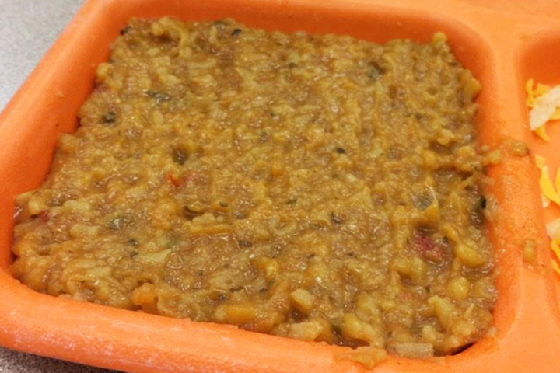
Hunter Whitney posted this "mystery mush" school lunch to Twitter with the sarcastic #ThanksMichelleObama hashtag.Photo: AP
WASHINGTON — School kids are giving thanks to first lady Michelle Obama just in time for the holiday – with a sarcastic Twitter hashtag about unappealing school lunches. Along with photos of unsavory-looking school meals, the hashtag #ThanksMichelleObama was among the top trends on Twitter within the United States for a time on Friday.
The first lady has become the symbol of healthier school meals as she has pushed standards implemented in 2012 that require more fruits, vegetables and whole grains in the lunch line in an effort to combat childhood obesity. There are also limits on sodium, sugar and fat. While many schools have put the standards in place successfully, others have said some of the new foods end up in the trash can.
Many of the photos have a Thanksgiving theme – think sad-looking stuffing – while others are everyday meals. The hashtag appears to have started around two years ago, but didn’t really catch on until Friday after several websites picked it up. “Had a very #healthylunch today,”
Hunter Whitney of Wisconsin tweeted. “The apple definitely made up for the `mystery mush’ #ThanksMichelleObama.” His photo of a soupy Spanish rice gone wrong and an apple on a school lunch tray was retweeted more than 170 times. Hunter, 17, is a senior at Richland Center High School in Richland Center, Wisconsin. He said in an interview with The Associated Press that his school lunches have gone downhill over his four years in high school. Of the Spanish rice, he said “you couldn’t feel the individual grains of rice. It was just a solid mush.”
Halana Turner, a junior at Fraser High School in Fraser, Michigan, posted a photo of a mushy breakfast sandwich Friday morning. She says she used to like the meals at her school.“I don’t blame my school for this because I know that they’re just following the rules,” she said.
To combat the critics, a handful of kids posted photos of more appetizing lunches. Some people joked that the students are far from the first generation to complain about their school lunches. The Center for Science in the Public Interest, a Washington advocacy group that has lobbied for the healthier lunches, got in on the game as well, tweeting pictures of colorful salad bars and happy kids under the hashtag. “Even if the lunches were super unhealthy, there would be kids who would complain,” said CSPI’s Margo Wootan.
The White House didn’t have an immediate response, but an Agriculture Department spokesman said most meals aren’t as bad as the photos depict. USDA oversees the school meals program. “Students are always provided full servings of both fruits and vegetables as well as protein options, so clearly many of the photos posted do not fully reflect the full range of choices students are provided,” said USDA’s Cullen Schwarz.
House Republicans are pushing a one-year waiver that would allow some schools to opt out of healthier meal standards if they lost money on meal programs over a six-month period. The schools pushing for changes say limits on sodium and requirements for more whole grains are particularly challenging, while some school officials say kids are throwing away fruits and vegetables they are required to take. The proposal drew a White House veto threat, and the first lady aggressively lobbied against it.
“I’m going to fight until the bitter end to make sure that every kid in this country continues to have the best nutrition that they can have in our schools, because these kids, all of these kids, are worth it,” she said this summer.

Kids ‘Thank’ Michelle Obama for ‘Mystery Mush’ School Lunches Questions
1. What hashtag was being used to protest unappealing school lunches?

2. Why has first lady Michelle Obama become the symbol of healthier school meals?

3. Critical Thinking: Do you think childhood obesity is a problem in the United States? Explain.

4. Critical Thinking: Why do you think students turned to Twitter to voice their complaints?

5. Why doesn’t Halana Turner blame the school for the bad lunches?

6. To combat the critics what are some students doing?

7. What did the Agriculture Department say in defense of the school lunches?

8. Critical Thinking: Why do you think President Obama would threaten to veto a bill that would give school a waiver on serving healthier lunches? Explain.

9. Critical Thinking: Do you think the food served at Henry Clay is good? Explain your view.

10. Critical Thinking: What could schools do to make lunches healthy and taste good? Explain.

