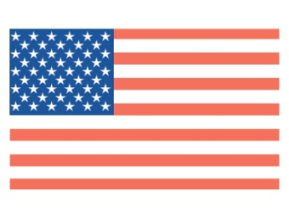
2019-2020
Jay Ogden Essay Contest

Sponsored by
THE LEAGUE OF WOMEN VOTERS®
OF LEXINGTON

First Place: $250 cash
Second Place: $150 cash
Third Place: $100 cash
Special Recognition for ESL Writing: $100
Honorarium to the Teacher/Sponsor of Each Winning Writer

This contest honors the late Jay Ogden, a longtime LWV member who believed students should be prepared to be informed citizens. As informed citizens, we examine events around us and form educated opinions that shape what we say and do. This contest is offered as an opportunity to think about an issue and then, through the writing process, to develop and explain a position on the topic.

PROMPT: WHY DO ELIGIBLE YOUNG VOTERS (AGES 18-29) HAVE LOWER VOTING RATES
THAN OLDER VOTERS?

The U.S. Election Project, which analyzes census data, finds that 18-to-29-year-olds have the lowest voting rate compared to all other age groups. Even though 18-to-29-year-olds saw the greatest increase in voting of any age group in 2018, they have a voter turnout rate that consistently remains at least 20 percentage points lower than all older voting age groups despite these increases.

To determine why, we ask you to seek related information, identify it as proper source material, and include information gathered through interviews with at least 5 people from the 18-29 age bracket. Compose a
well-crafted analysis of the problem citing the written material and your oral interviews.

Rules:
- This contest is open to students in grades 9-12 who are attending any Fayette County school or participating in any Fayette County homeschooling network in those same grade levels.
- Essays are to be printed double-spaced, using Times New Roman 12-point font (or equivalent), and should be a maximum of three pages excluding the title page and references, if used.
- Essays should be fact-based, thoughtful, organized writings.
- The deadline for submission is Friday, December 6, 2019. Awards will be presented in February 2020. Entering contestants should submit the following:

- Title Page - Submit all information requested on the attached Essay Title Page form.
2. The Essay - Follow the rules printed above for content and format.

Essays mailed to:
LEAGUE OF WOMEN VOTERS OF LEXINGTON
P.O. Box 22045, Lexington, KY 40522-2045
Must be postmarked no later than Friday, December 6, 2019.

Email submissions may also be made by midnight on December 6, 2019
to Theresa McCarty at lwvlexessay@gmail.com
Questions may be submitted to the above email address at any time. Information on the Essay Contest can be found at www.lwvlexington.com.

