Digital Tech Is Boosting Workers’ Productivity
1. According to the Pew Research Center what percentage of people indicated that email ,internet, and smart phones made them feel more productive?

2. Critical Thinking: Why would people have greater difficulty separating themselves from the work because of these devices?

3. Why did there used to be a sharp boundary between work and home?

4. What can people now do at work that they used to not be able to do?

5. Critical Thinking: In what ways have the internet and smart phones made students more productive? In what ways have they made students less productive?

6. On average how many hours do people in the United States work on average?

7. Critical Thinking: Why do you think people in the United States work more compared to people in other countries? Explain your answer.

8. What digital tool was identified as most important?

9. Critical Thinking: Do you think e-mail will remain important for work for the next five years or will something replace it? Explain your answer.

10. Critical Thinking: Do you believe that the increase in technology available to workers has been mostly good or mostly bad? Explain your opinion.

Pew Survey: Digital tech is boosting workers’ productivity — but also keeping them on an ‘electronic leash’
By Dan Taylor, National Monitor | December 30, 2014
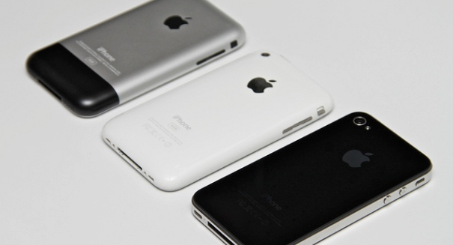

But there is a flipside to it, too: people can now do things they could only do at work at home as well.
They may be time-wasters much of the time, but all of those digital conveniences we rely on today — email, Internet, and smartphones — really do markedly increase our productivity, according to a new study.
A Pew Research Center report indicates that 46 percent of all workers who use these tools say they feel more productive, according to USA Today.
Of course, it also means that people have longer workdays and have greater difficulty separating themselves from work once they leave the office. About 39 percent of respondents said that the Internet, email, and their phones give them added “flexibility” in what hours they work, which has led 35 percent to say that they are working more hours because of these tools.
Lee Rainie, director of Internet, science, and technology research at Pew, said in the USA Today report that there used to be a sharp boundary between work at home, because once most people left the office, they couldn’t do more work even if they wanted to. Now that they can, more people are choosing to get just a little bit more done after office hours.
But there is a flipside to it, too: people can now do things they could only do at work at home as well. In the past, the only diversion from work would have been chatting with coworkers by the watercooler or reading the newspaper. Now people can do things they’d do at home, like shop, surf the Internet, or even watch sporting events on their smartphones.
The findings came from a Pew survey of 1,000 adults in September, focusing on 535 adults who worked either full or part time.
It’s not definitive proof that people are more productive now because of these digital tools, but it certainly suggests that people feel that way. Part of the reason is they feel more “on call,” allowing bosses to use the “electronic leash” to get them back to work even during off hours or while on vacation, Rainie said in the report.
People in the United States tend to work, on average, 1,790 hours per year, which is about 25 hours more than people in other countries. Also, about 11 percent of U.S. workers deal with very long hours, compared to 9 percent elsewhere.
The research found that email was considered an important tool at 79 percent, followed closely by the Internet at 76 percent. The smartphone scored only 47 percent, compared to 62 percent for a landline phone. Finally, socially networking sites were considered at least somewhat important by 18 percent of those surveyed.
Email has survived as the most important digital tool for a long time now, despite many predictions that other communication tools would eventually supplant it. While there are many new communications tools out there that have proven very popular, none so far challenge email as the predominant way to communicate in the workplace.

