Batman and Vigilante Justice
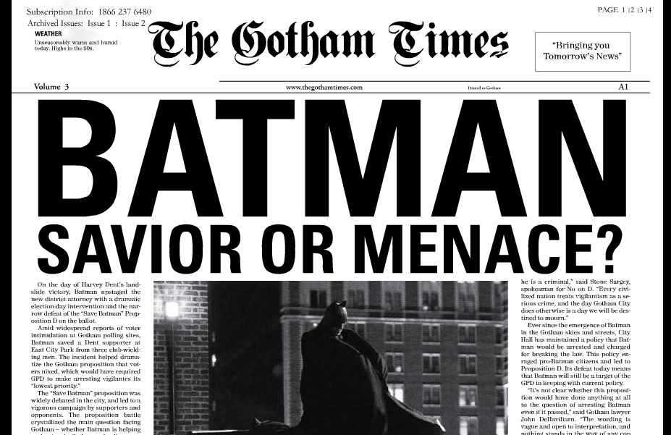

The caped superhero Batman has many fans in the city of Gotham. Many citizens see Batman as the lone figure in the city who has the willingness and tools to stand up to the criminal organizations in the city. Batman’s vigilante status also allows him to avoid the rules and corruption that can constrain the police and other government agencies. However, Batman’s willingness to ignore rules has brought him under criticism from some citizens and civil rights groups. They have lobbied the city leadership to hold Batman accountable for his actions and have him follow guidelines in his behavior. As an expert in criminal justice, you have been tasked with advising the mayor on how to deal with the “Batman issue.” You will need to council the mayor on whether he should attempt to prevent Batman from operating in Gotham, should allow Batman to continue operating in Gotham but under certain guidelines, or whether Batman should be allowed to operate without any constraints from government. The mayor will be expecting a detailed explanation with sound legal logic to support your position.

Prewriting:
Option | Advantages | Disadvantages
Stop Batman
Batman with rules and limits
Batman without rules

Sample outline:
Paragraph 1: Introduction
-Explain the topic
-Thesis: your view on the issue, what should we do about Batman?
Paragraph 2: Body Paragraph
-Give one supporting reason for your thesis and explain in a well develop paragraph
Paragraph 3: Body Paragraph
-Give one supporting reason for your thesis and explain in a well develop paragraph
Paragraph 4: Body Paragraph
-Give one supporting reason for your thesis and explain in a well develop paragraph
Paragraph 5: Conclusion
-Summarize your main points and thesis

***Remember to make a well-developed argument for or against something, it is good practice to address counter claims from the opposing side of the argument
THIS IS A TEST GRADE, TAKE IT SERIOUSLY, THIS SHOULD BE SOME OF YOUR BEST WORK

Formatting | -Paper has significant errors in formatting structure  -Paper is significantly shorter than required  -Paper has significant “typo issues” and shows little evidence of proofreading  *0 points | -Paper has some errors if formatting structure  -Paper is shorter or longer than required  -Paper has some “typo issues” and shows some evidence of proofreading  *1 to 10 points | -Paper has no or minor error errors in formatting structure  -Paper is required length  -Paper has no or few “typo issues” and shows evidence of proofreading  *11 to 15 points
On Time | -Papers may not be turned in more than one week late in most circumstances  *Zero for the assignment | -Papers may be turned in up to one week late in most circumstances  *Late papers will automatically lose 30 points | -Paper is typed and printed out or neatly handwritten and ready to turn in at the start of class  or  -Paper is typed and e-mailed to teacher before the start of class  *10 points
Thesis/Argument | -Paper lacks a clear and meaningful thesis/ argument  *0 points | -Paper attempts to develop a clear and meaningful thesis/ argument  *1 to 14 points | -Paper has a clear and meaningful thesis/ argument  *15 points
Organization/Focus | -Paper lacks focus on the thesis  -Paper’s organization distracts from the purpose  -Paper fails to develop thoughts and ideas  *1-9 points | -Paper occasionally lacks focus on the thesis  -Paper’s organization occasionally distracts from the purpose  -Paper sometimes fails to fully develop thoughts and ideas  *10-25 points | -Paper rarely or never lacks focus on the thesis  - Paper’s organization rarely or never distracts from the purpose  -Paper rarely or never fails to fully develop thought and ideas  *25-30 points
Persuasiveness | -Paper largely fails to provide logical arguments as support  -Paper largely fails to grab a reader’s attention  -Paper largely fails to clarify the issue for the reader  *1-9 points | -Paper sometimes fails to provide logical arguments as support  -Paper sometimes fails to grab a reader’s attention  -Paper sometimes fails to clarify the issue for the reader  *10-25 points | -Paper mostly or always provides logical arguments as support  -Paper mostly or always grabs the reader’s attention  -Paper mostly or always clarifies the issue for the reader  *25-30 points

Total Score: _________________/100 points
Comments:

