How video changed Americans' views toward the police, from Rodney King to Alton Sterling
German Lopez
Published: July 6, 2016
This piece originally appeared in Vox.
Another video of a police shooting has once again put attention on racial disparities in the criminal justice system. On Tuesday, police shot and killed Alton Sterling in Baton Rouge, Louisiana. The video shows police pinning Sterling down, then shooting him after allegedly seeing a gun.
Video has been changing Americans' views toward police for more than 25 years. In 1991, four white Los Angeles police officers brutally beat Rodney King, an unarmed black man, as it was caught on video, sparking local riots and putting a spotlight on longstanding feelings of distrust toward law enforcement in minority communities. The video in particular has been credited with forcing cities to reconcile with — and sometimes reform — how they police minority neighborhoods.
With the rise of the Black Lives Matter movement over the past two years, this issue is once again in the national spotlight. Activists have pushed prosecutors across the country to take excessive use of force by police more seriously and, in some cases, file charges against cops. And as Gallup found, public confidence in police has generally declined — to levels not seen since the Rodney King riots.
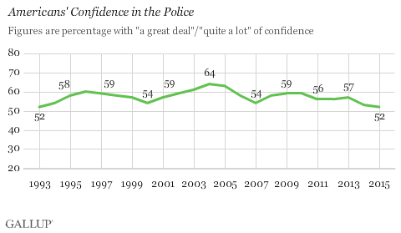Gallup
Behind this trend is one critical factor: video. The proliferation of video through smartphones, dashboard cameras, and body cameras — and social media's ability to send a video into viral overdrive — has played a major role in holding police accountable, especially this year.
At the very least, video has helped weaken the infallibility that once seemed to surround police — a sense that allowed officers' testimony to be viewed as more credible than testimony of those who lodged complaints against them.
"Before you had complaints, police stories, and witnesses' stories," Athena Mutua, a civil rights scholar at SUNY Buffalo Law School, said. But video, paired with its spread on social media, "was important in getting protesters taken seriously."
In the past couple of years, there were several videos that stood out — showing different kinds of use of force that protesters described as excessive and helping expose the racial disparities in America's criminal justice system.
For instance, an analysis of the available FBI data by Vox's Dara Lind found black people accounted for 31 percent of police killing victims in 2012, even though they made up just 13 percent of the US population. Although the data is incomplete, since it's based on voluntary reports from police agencies around the country, it highlights the vast disparities in how police use force.
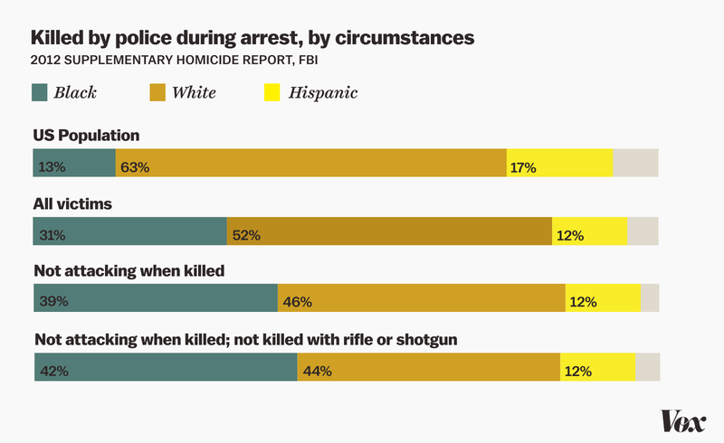
Joe Posner/Vox
But we've known about these statistics for decades. It's only recently that they got a serious amount of mainstream attention — and, as Mutua explained, video played an enormous role in getting that attention.
Here are some of the videos that have stood out in the past few years.

1) Freddie Gray in Baltimore
The video of Freddie Gray's arrest in Baltimore on April 12, 2015, didn't reveal much. It showed police carrying the 25-year-old black man to a police van while he appeared to limp. But it didn't show police using excessive force or necessarily mistreating Gray. Instead, it would be Gray's treatment in the police van that would kill him: Gray received a fatal spinal cord injury after thrashing around the back of the vehicle without a seat belt, all while his pleas for medical help went ignored.
But in Baltimore, a city plagued by decades of complaints of police brutality, his fate sparked massive protests and riotsagainst police.
Still, Gray was no anomaly: A September 2014 report by Mark Puente for the Baltimore Sun found, for instance, that the city had paid about $5.7 million in settlements since 2011 to more than 100 people — most of whom were black — who claimed that officers had beaten them, although police didn't admit fault in those cases. And critics of Baltimore police blamed Gray's death on a practice cops had allegedly used in the past: "rough rides" in which handcuffed detainees are driven in a reckless manner while they're not wearing seat belts — all to purposely cause injuries.
The video helped put a face on these issues. Even though no abuse by police was evident in the video, Gray's screams of apparent pain and limping gave the movement the initial credibility it needed to have its complaints against police taken seriously, culminating in criminal charges against the cops involved in Gray's death.

2) Walter Scott in North Charleston, South Carolina
Warning: Graphic footage of a police shooting:
On April 4, 2015, 50-year-old Walter Scott was unarmed, facing away from the police officer, and haphazardly attempting to flee — but that didn't stop Michael Slager, a North Charleston, South Carolina, police officer at the time, from firing his gun at least eight times at the fleeing man, killing him.
The video, recorded by a bystander, was monumental in this case. Prior to the video's release, Slager claimed that Scott had attempted to take his stun gun and use it on him during a struggle before he opened fire. But the video shows no struggle; Slager shoots Scott to death while Scott attempts to flee. And at the end of the video, Slager appears to actually pick up the stun gun and plant it near Scott's body.
It was a shooting so outrageous that even conservative defenders of police spoke out against it. Fox News's Sean Hannity, for one, argued there was no justification for this shooting: "If he's not a threat to the officer, or a threat to anybody else, there is never a justification in terms of tactics and techniques and training. There's no justification for what I see on that video. None."
This was a defining moment for protests of police use of force. Up to that point, the events surrounding these cases — such as those of Michael Brown and Freddie Gray — were left largely to interpretation, since there wasn't a video showing what, exactly, happened.

3) The pool party in McKinney, Texas
On June 5, 2015, several teens — many of whom were black — attended a pool party in suburban McKinney, Texas. But pretty soon, police crashed the cookout after receiving reports from locals that the teens were trespassing at the suburban community's pool.
Things escalated from there. Eric Casebolt, a police officer at the time, dashed into the scene — screaming, "Move!" and doing what can only be described as a barrel roll — before confronting some teens.
After a few minutes, Casebolt, who was clearly upset and yelling profanities throughout the video, confronted Dajerria Becton, a 15-year-old, bikini-clad black teen. He then grabbed her and slammed her to the ground, even though she seemed to pose no threat to anyone around her. When some of the girl's peers confronted him to ask what he was doing, he pulled out a gun, at which point the teens dispersed.
After all that, he went back to the girl, and slammed her face to the ground and restrained her.
Protesters quickly criticized Casebolt for using excessive force — and he resigned a few days later.
Although it's impossible to say what, exactly, Casebolt and other police officers were thinking, the video, even beyond Casebolt's actions, appeared to show police officers specifically targeting black teens in the mixed-race crowd.
POLICE OFFICERS AND THE GENERAL PUBLIC ARE MORE LIKELY TO ASSOCIATE BLACK PEOPLE, EVEN KIDS, WITH CRIMINALITY
There's a potential explanation for this: subconscious prejudices against certain groups of people known as "implicit bias."
As part of a study published in the Journal of Personality and Social Psychology in 2014, researchers studied 176 mostly white, male police officers, and tested them to see if they held an unconscious "dehumanization bias" against black people by having them match photos of people with photos of big cats or apes. Researchers found that officers commonly dehumanized black people, and those who did were most likely to be the ones who had a record of using force on black children in custody.
In the same study, researchers interviewed 264 mostly white, female college students and found that they tended to perceive black children age 10 and older as "significantly less innocent" and older than their white counterparts.
Again, it's impossible to say what was going on in the police officers' minds. But police officers and the general public are more likely to associate black people, even kids, with criminality. That not only may have led a bunch of white parents to call the police on black teens at a pool, but it may have encouraged police to use far too much force.
The video of the police response essentially gave a real-life example to this problem, which has been widely backed in the empirical research. By showing what seemed like a serious overreaction by parents and police to a pool party, it became much easier to believe that implicit bias is a real, dangerous phenomenon.

4) Sandra Bland in Waller County, Texas
The video of Sandra Bland's arrest in Texas did not show a police officer shooting, killing, or even using force on someone. But what it did reveal is how police officers can sometimes cause situations to escalate entirely unnecessarily. In Bland's case, her arrest for a minor infraction led to her death — according to autopsy reports, she killed herself a few days later in a jail cell after officials failed to account for her medical history.
On July 10, 2015, a Texas trooper, Brian Encinia, pulled over Bland for allegedly failing to signal while changing lanes. The video shows the stop was calm at first, but it escalated once the trooper asked Bland to put out a cigarette.
Bland asked, "I'm in my car. Why do I have to put out my cigarette?" The trooper responded by asking her to get out of the car. When Bland didn't comply, Encinia opened her car door and attempted to pull her out. When that didn't work, Encinia pulled out his stun gun, aimed it at Bland, and said, "I will light you up." At that point, Bland got out of the car, and a struggle ensued before Encinia arrested her, eventually sending her to the jail where she would die.
THE ENTIRE ESCALATION COULD HAVE BEEN AVOIDED IF THE POLICE OFFICER HAD JUST LET SANDRA BLAND KEEP HER CIGARETTE
As I wrote after the video was released, the entire escalation could have been avoided if Encinia had just let Bland keep her cigarette. It's hard to see what harm would come to Encinia or the public if Bland had just been allowed that one refusal. In fact, it might have reduced harm — a struggle wouldn't have taken place, Bland wouldn't have been arrested, and she wouldn't have died in that jail cell.
It's true that Bland could have just obeyed, and the situation might not have escalated. But smoking isn't illegal, so Bland wasn't violating any laws by smoking in her car. (Although, asReason's Jacob Sullum pointed out, that may not give Bland the legal right to disobey the cop.)
But it's the police officer's — not the civilian's — explicit job to make sure a situation doesn't escalate. Failure to do this was the main complaint of how law enforcement handled the Ferguson, Missouri, protests after the police shooting of Michael Brown last August: They consistently used too much force, even against relatively peaceful crowds, causing the situation to spiral into mayhem.
The video of Bland's arrest reinforced that narrative, showing that sometimes police officers cause things to escalate when there's simply no need for it. And it eventually led to Encinia's firing.

5) Samuel DuBose in Cincinnati
On July 19, 2015, a routine traffic stop turned deadly.
University of Cincinnati police officer Ray Tensing, who was wearing a body camera, stopped Samuel DuBose, a 43-year-old black man, because his car was missing a front license plate. Tensing asked DuBose for a driver's license, which the 43-year-old didn't have at the time. Tensing then asked DuBose to take off his seat belt and get out of the car, which DuBose didn't do.
The car then began moving forward very slowly. Tensing quickly fired a single shot into the driver's window, hitting DuBose in the head and killing him.
The local prosecutor on the case described the shooting in no uncertain terms when he announced murder and voluntary manslaughter charges against Tensing. "This is the most asinine act I've ever seen a police officer make," Hamilton County Prosecutor Joe Deters said. "It's an absolute tragedy in 2015 that anyone would behave in this manner. It was senseless."
It was a forceful statement from a Republican prosecutor who has repeatedly sided with police over the years. But in this case, the video did more than just show an unnecessary shooting — like the Scott shooting in North Charleston, it showed how officers can try to cover up their actions.
"THIS IS THE MOST ASININE ACT I'VE EVER SEEN A POLICE OFFICER MAKE"
The incident report filed by University of Cincinnati police falsely claimed Tensing was dragged by the car, and that he was almost run over by the vehicle.
Based on the video, though, the timeline of these claims don't match up. The car started moving very slowly — to the point that it's hard to make out whether it was moving at all. Within seconds, Tensing reached into the vehicle and shot DuBose in the head. Tensing then fell over, stumbling a good distance away from the car.
Tensing doesn't appear to be attached to and dragged by the vehicle, and he's never close to being run over. When he falls over after firing the shot, he's so far away from the car that he has to run after it as it accelerates. (DuBose's body appears to have fallen against the pedal after he was shot dead, causing the vehicle to accelerate, according to Deters.)
Without the video, it's much less likely that a grand jury would have agreed to an indictment for murder and voluntary manslaughter, and the prosecutor on the case might not have been so confident that a murder charge was called for.
"There is a tendency to believe an officer over a civilian, in terms of credibility," David Rudovsky, a civil rights lawyer who co-wrote Prosecuting Misconduct: Law and Litigation, previously told Vox's Amanda Taub. "And when an officer is on trial, reasonable doubt has a lot of bite. A prosecutor needs a very strong case before a jury will say that somebody who we generally trust to protect us has so seriously crossed the line as to be subject to a conviction."
The video, then, didn't just lead to Tensing being charged. It also helped show that, just like everyone else, police can be unreliable witnesses — especially when they're the ones facing charges and trial.

6) Laquan McDonald in Chicago
The most recent video to lead to protests against police use of force is actually more than 13 months old.
Laquan McDonald didn't appear to pose a threat to the people around him as he haphazardly ran down a Chicago street on October 20, 2014, allegedly carrying a knife but keeping his distance from the police cars parked around him. But police officer Jason Van Dyke nonetheless approached McDonald from at least 10 feet away and fired 16 shots, even after the black 17-year-old fell to the ground.
After the video was released, the local prosecutor charged Van Dyke with murder — a fact that didn't stop a successful challenge against prosecutor Anita Alvarez's reelection prospects, since many felt she still mishandled this and other instances of police brutality. The US Department of Justice also announced it will investigate the Chicago Police Department for a pattern and practice of excessive use of force, particularly against racial minorities.
The Justice Department carried out a similar investigation against the Ferguson, Missouri, Police Department after the Michael Brown shooting, finding a pattern of racial bias in that department's policing. But the investigation into the Chicago Police Department is the largest the Justice Department has ever taken against a city, the Huffington Post's Ryan Reillyreported.
This makes the Justice Department's investigation potentially groundbreaking, since it shows even some of the biggest police departments in the US aren't above accountability. But, as with the other cases on this list, it may not have been possible without the video and the public outcry it caused.

The latest: Alton Sterling in Baton Rouge, Louisiana
According to the Advocate, Baton Rouge police officers responded to a call at a convenience store around 12:35 am Tuesday after receiving an anonymous tip that a man in a red shirt who was selling CDs had pointed a gun at someone. Alton Sterling, a 37-year-old black man, matched part of the description: He sold CDs, and he was wearing a red shirt.
A short cellphone video captured by a bystander shows what happened next: Two police officers yelled at Sterling to get on the ground. The officers then pulled him to the ground, pinning him on his back. An officer yelled, "He's got a gun!" The video shows an officer holding down Sterling’s left arm, but Sterling’s right arm isn’t visible. One officer aimed his gun at Sterling’s chest — at what seems to be point-blank range. Within seconds, at least one officer opened fire. Sterling was pronounced dead shortly after.
SHOP OWNER ABDULLAH MUFLAHI TOLD THE ADVOCATE THAT THE OFFICERS WERE "AGGRESSIVE" FROM THE START
Shop owner Abdullah Muflahi told the Advocate that the officers were "aggressive" from the start, and that Sterling was armed but was not holding his gun and didn’t have his hand near his pocket at the time of the shooting.
Both officers are on administrative leave, per Baton Rouge Police Department policy, and an investigation is underway. Both officers were reportedly wearing body cameras, and the police car had a dashboard camera as well.
As several media outlets reported, Sterling had a criminal record. But his previous convictions aren’t relevant to the shooting; it’s whether he was holding and trying to use a gun on the officers at the time he was shot. The legal standard for use of force requires officers to reasonably perceive a threat at the moment of use of force.
Since Sterling was seemingly immobile in the video of the shooting, critics argue that he was not in fact a threat and the shooting is another example of excessive use of force against a black man.

This piece originally appeared in Vox.
You can follow German on Twitter at @germanrlopez.
Posted in JPI in the News, Criminal Justice News

